Continued Development

**The Habits of Effective Artists**

* https://www.youtube.com/watch?v=vM39qhXle4g
* Andrew Price at Blender Conference 2016

1. **Daily Work** 
   1. **Small Breaks vs Big Breaks** (Marathon vs Short Sprints)
      1. Life happens
      2. Everyone has responsibilities
      3. Lack of free time
      4. Motivation is difficult
      5. Start with the smallest amount of work possible
   2. **Volume > Perfection**
      1. Perfection slows you down
      2. 90% of learning occurs during the first 60% of doing
      3. Expanding horizons increases your ability to learn
      4. Lots to show > nothing
   3. **Steal**
      1. We build on what we see
      2. *Steal Like an Artist – Austin Kleon*
         1. Good vs Bad stealing
         2. Credit, not plagiarize
         3. The life of a project
         4. Is it worth stealing?
         5. The secrets
      3. Find projects you like the idea behind, see how they started
      4. Steal code to see how it works, build it yourself
   4. 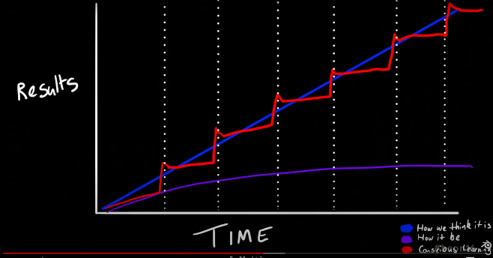**Conscious Learning** 
      1. Practice -> Procrastination
      2. Learning is not linear
      3. Have goals, don’t just doodle
      4. Re-Learn
      5. Fastest way to improve
   5. **Rest**
      1. Burnout kills learning
      2. Step away when stumped
      3. Reading your projects after a break
   6. **Feedback** 
      1. Best artists seek *honest* feedback/ criticism
      2. Iteration > One and done
   7. **Create what You Love**
      1. Make the projects that would inspire you
      2. Create things you want to use
      3. Intrinsic motivation

**Effectiveness of Routine:**

Humans are creatures of habit and routine. While this focus is on productivity and learning, routine is important in all aspects of life and our health.

More research and health issues related to lack of routines can be found by Northwestern Medicine, <https://www.nm.org/healthbeat/healthy-tips/health-benefits-of-having-a-routine>

Taking on projects can introduce stress, and affect your sleep and normal habits.

Routines should *help* your health and lead your projects in a healthy manner.

Balance

Responsibility

12 Rules for Life